als

Company Setup

  - User Guide

Insperity™, a trusted advisor to America’s best businesses for more than 26 years, provides an array of human resources and business solutions designed to help improve business performance.

Insperity and the compass icon, and the Inspiring Business Performance tagline are trademarks of Insperity, Inc.

Microsoft and Internet Explorer are registered trademarks of Microsoft Corporation in the United States and/or other countries.

Google and Chrome are trademarks of Google Inc.

Mozilla and Firefox are registered trademarks of the Mozilla Foundation.

The information contained in this document is subject to change without notice. Nothing in this document should be construed as constituting an additional warranty. Insperity shall not be liable for technical or editorial errors or omissions contained in this document.

Copyright © 2018 Insperity.
All Rights Reserved.

First Edition: March 2018

Contents
Introduction 3
Holidays 3
Navigating to the Holidays Page 3
Reviewing the Holidays Page 4
Generating Holidays 4
Editing and/or Deleting Holidays 5
Pay Periods 6
Navigating to the Pay Periods Page 6
Reviewing the Pay Periods Page 7
Generating Pay Periods 7
Editing and/or Deleting Pay Periods 8
Organization Level Items 9
Navigating to the Organization Level Items Page 9
Reviewing the Org Level Items Page 10
Organization Level Item Field Definitions 10
Editing an Organization Level Item 11
Adding an Organization Level Item 11
Deleting an Organization Level Item 11
Frequently Asked Questions 12
Once I have generated the holidays for the upcoming year, what will happen? 12
A holiday is not showing in an employee’s timesheet. What could be wrong? 12
My company is observing a new holiday, what do I need to do in Time and Attendance? 12
Different groups of employees observe certain holidays on different dates. How do I set this up? 12
An Organization Level Item that my employee must allocate time to is unavailable for selection. What could be wrong? 13
Can I restrict Organization Level Item selection from certain employee(s)? 13

Introduction
The Company Setup area of Time and Attendance is used to make changes to set up options that are specific to each company. The main two sections that Administrators may have access to include Holidays, Organization Level Items, and Pay Periods.

Holidays
The Holidays page is used for Administrators to set up the dates of company holidays from year-to-year to automatically appear in eligible employees’ timesheets. Determining how holidays should apply to various groups of employees should be discussed with the Time and Attendance representative who will configure and maintain those rules in a separate area of the system.

Navigating to the Holidays Page
- In the Main Navigation menu, open the Company Setup folder.
- Click on the Holidays page.
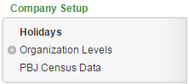

Reviewing the Holidays Page
1
3
2
4

- Holidays – Lists the holiday name and their corresponding dates for the year selected
  - Holiday – Holiday Name
  - Date – Date in which the company observes the holiday
  - Trash – Removes the holiday from the list for the listed year
- Calendar Year Selection – Selects the year of holidays to display
- Additional Tools
  - Print – Prints data displayed on the page
  - Online Help – Launches Time and Attendance online help for the Holidays page
- Add Holiday – Adds additional holidays to the year selected by using the Plus button

Generating Holidays
Holidays should be generated in advance of the coming year to ensure that they appear on the timesheets of the employees who are eligible to receive holidays. To generate holidays, follow the below steps:
- If not yet on the Holidays page, follow the steps in the “Navigating to the Holidays Page” section.
- Once on the Holidays page, click on the Generate Holidays button.
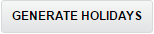
The Detail View pop-up window launches.
- Select the year to generate dates from in the Generate dates from drop down.
- Fill in the year to generate dates for in the Generate dates for field.
- Click the Generate Holidays button.
The holidays for the determined year will appear.
- Use the Date column to adjust the dates in which the holidays are observed as necessary. When the field is clicked, a calendar will appear. Dates can either be selected using the calendar, or by highlighting the date text and typing over it.
- Click Save.
The generated holidays will save. Future year holidays can be viewed by adjusting the Select Calendar Year to View drop down on the main Holidays page.

Editing and/or Deleting Holidays
To edit a date of a holiday, the holiday must be deleted and re-added with the correct date. This will allow the incorrectly dated holiday to be removed from employee timesheets prior to adding the corrected holiday. Follow the below steps to edit and/or delete a holiday:
- If not yet on the Holidays page, follow the steps in the “Navigating to the Holidays Page” section.
- Find the row of the holiday to edit or remove. Click the Trash button.
- Click the Save button.
A pop-up window launches to confirm the deletion. Click OK.
To add the holiday with a new date, continue through the steps below:
- Open the Add Holiday drop down to select the holiday to add to the list. Click the Plus button adjacent to the drop down.
The holiday will add to the list below.
- Use the Date column to adjust the date as necessary. When the field is clicked, a calendar will appear. Dates can either be selected using the calendar, or by highlighting the date text and typing over it.
- Click Save.

Pay Periods
The Pay Periods page is used for Administrators to set up the dates of the pay periods from year-to-year to become available in the system. This step is mandatory in ensuring the Time and Attendance system continues to work smoothly. Administrators may set up pay periods as many years in advance as they wish, or make it a yearly occurrence. S

Navigating to the Pay Periods Page
- In the Main Navigation menu, open the Company Setup folder.
- Click on the Pay Periods page.
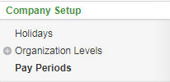

Reviewing the Pay Periods Page

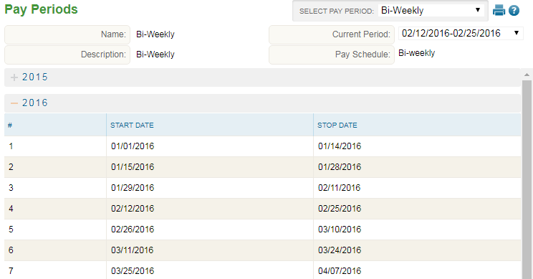
2
5
4
3
1

- Pay Periods – Lists the years and thee corresponding dates for each pay period start/stop date for the pay period selected in section 2.
- Select Pay Period – Selects the Pay Period to review/edit/generate
- Additional Tools
  - Print – Prints data displayed on the page
  - Online Help – Launches Time and Attendance online help for the Pay Period page
- Current Period – Current Pay Period active in the system
- Pay Schedule – Type of Pay Period selected

Generating Pay Periods
Pay Periods should be generated in advance of the coming year to ensure that they appear on the timesheets and allow normal functionality to continue. To generate Pay Periods, follow the below steps:
- If not yet on the Pay Periods page, follow the steps in the “Navigating to the Pay Periods Page” section.
- Once on the Holidays page, use the Select Pay Period drop down to choose the Pay Period type to generate.
- Click on the Generate Dates button.
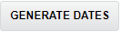
The Detail View pop-up window launches.
- Select the year to generate dates for in the Year drop down. Note: If the year in the list has no dates in parenthesis next to it, it does NOT yet have Pay Periods generated.

The Initial Date field will fill in automatically based on the previous year’s final pay period’s end date.
- Click the Generate Dates button.
The dates for the determined year will appear.
- Use the Start Date and End Date columns to adjust the dates for the Pay Periods if necessary. When the field is clicked, a calendar will appear. Dates can either be selected using the calendar, or by highlighting the date text and typing over it.
- Click Save.
The generated Pay Periods will save. Future and past pay periods can be viewed on the main Pay Periods page by clicking on the plus drop down to the left of the year, expanding the list to view its start/end dates.
- Repeat steps 2-7 for additional Pay Periods if necessary.

Editing and/or Deleting Pay Periods
To delete a Pay Period, it must be removed in its entirety using the Delete button. Follow the below steps to edit a Pay Period:
- If not yet on the Pay Periods page, follow the steps in the “Navigating to the Pay Periods Page” section.
- Once on the Pay Periods page, use the Select Pay Period drop down to choose the Pay Period to edit.
- Find the year of Pay Periods to edit in the main section of the page. If not already open to view each start/end date, click on the plus drop down to the left of the year to do so.
- Select the date field to edit. When the field is clicked, a calendar will appear. Dates can either be selected using the calendar, or by highlighting the date text and typing over it. Repeat this step for all remaining fields.
- Click the Save button.

Organization Level Items
Organization Level Items are often used to allow for reporting based on organization items and/or job costing. The Organization Level Items page is used to create the items that will be attached to or selected by the employees. Should these items also be syncing to a payroll system, the names created here must match exactly to the ones in payroll.

Navigating to the Organization Level Items Page
- In the Main Navigation menu, open the Company Setup folder.
- Open the Organization Levels subfolder.
- Click on the Org Level Items page.
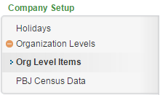

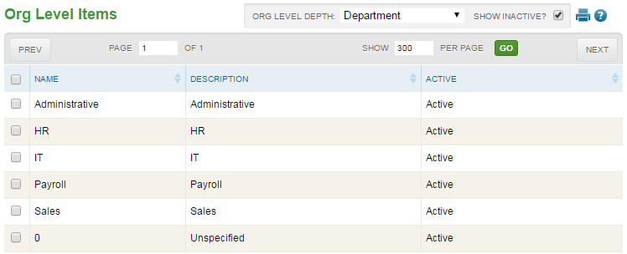
Reviewing the Org Level Items Page
1
3
2
4

- Organization Level Items – Lists the organization level items
  - Name – Name of Organization Level Item. If syncing with a payroll system, this must match the name in the payroll system
  - Description – Description of the Organization Level Item. Most often, this is the field that displays to employees when time allocating or job costing, as well as the information that displays in reports.
  - Active – Active/Inactive indicator. Inactive items will not be available for employee assignment or selection
- Page Selection – Move forward/back a page and determine the number of items to display per page
- Organization Level Depth Selection – Select an Organization Level in this drop down to see its Organization Level Items in the main section of the page
  - Show Inactive – Uncheck to hide all Inactive Organization Level Items
- Additional Tools
  - Print – Prints data displayed on the page
  - Online Help – Launches Time and Attendance online help for the Holidays page

Organization Level Item Field Definitions
Below is a list of the fields that may be seen on the main Organization Level Items page or within the Detail View pop-up window when editing or adding an item.
- Name – Name of Organization Level Item. If syncing with a payroll system, this must match the name in the payroll system
- Description – Description of the Organization Level Item. Most often, this is the field that displays to employees when time allocating or job costing, as well as the information that displays in reports.
- Active – Active/Inactive indicator. Inactive items will not be available for employee assignment or selection
- Org Depth – Selects the depth that the org level item belongs to.
- Assign to all parents?
    - Yes – Item is available for selection when any item in the organization levels above are chosen
    - No – Item is only available for selection when specific items in organization levels above are chosen. These items are to be specified in the Child of: field
- Child Of – Used to specify the items above in which the current item is available under

Editing an Organization Level Item
An Organization Level Item can be editing using the following steps:
- If not yet on the Org Level Items page, follow the steps in the “Navigating to the Organization Level Items Page” section.
- Click on the line of the item to be edited.
The Detail View pop-up window launches.
- Adjust the field(s) as needed. For definitions of each field, see the section titled “Organization Level Item Field Definitions.”
- Click Save.

Adding an Organization Level Item
To add a new Organization Level Item, follow the below steps:
- If not yet on the Org Level Items page, follow the steps in the “Navigating to the Organization Level Items Page” section.
- Select the Organization Level to add the item to using the Org Level Depth drop down.
- Click the Add button.
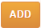
The Detail View pop-up window launches.
- Adjust the field(s) as needed. For definitions of each field, see the section titled “Organization Level Item Field Definitions.”
- Click Save.

Deleting an Organization Level Item
An Organization Level Item can be deleting using the following steps:
- If not yet on the Org Level Items page, follow the steps in the “Navigating to the Organization Level Items Page” section.
- Click the Check Box to the left of the item to be removed.
A warning message will appear to confirm the deletion of the punch.
- Click the Delete button.
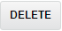
A warning message will appear to confirm the deletion of the punch.
- Click OK.

Frequently Asked Questions

Once I have generated the holidays for the upcoming year, what will happen?
Once the holidays are generated for the following year, every holiday will immediately appear in eligible employee’s timesheets. The determination of which employees are eligible to receive which holidays and for how many hours are determined by their assigned Pay Group and the rules established for that Pay Group in the background of the system.

A holiday is not showing in an employee’s timesheet. What could be wrong?
If a holiday is not showing up in an employee’s timesheet, there are a few things to check. First, using the Holidays page, verify that the holiday is created for the current year. Please also verify that the employee is assigned to the correct Pay Group. If both items are correct, contact your Time and Attendance representative to ensure that the rules in the background of the system are created correctly.

My company is observing a new holiday, what do I need to do in Time and Attendance?
In addition to adding the holiday to the Holidays page for the coming years, your Time and Attendance contact must be notified of a new holiday as it must be built into the rules in the background of the system.

Different groups of employees observe certain holidays on different dates. How do I set this up?
If the same holiday is observed on different dates for different groups of employees, variations on the name of the holiday should be created to distinguish one from the next – each with a different date of observance assigned on the Holidays page. For example, “Memorial Day – A” and “Memorial Day – B”. Your Time and Attendance representative should also be aware of these differences to ensure that the rules in the background of the system are created correctly.

An Organization Level Item that my employee must allocate time to is unavailable for selection. What could be wrong?
There may be a few reasons why an Organization Level Item might be unavailable for selection by an employee.
First, ensure that the item is active through the Holidays page.
Second, using the Holidays page, verify that the item either belongs to all parents above, or is assigned as a child to the parent item that has been selected by the employee. Please see the Organization Level Item Field Definitions section for more information on these fields.
Finally, check the employee’s User Security page for any restrictions to items through the Restrictions tab. For more information, please see the User Security Guide. Potentially, restrictions to these items can also be set by Security Group. Please contact your Time and Attendance representative for changes to this area.

Can I restrict Organization Level Item selection from certain employee(s)?
Organization Level Items can be restricted from selection by employee(s) through two methods. The first method is to restrict at the employee level through their User Security page within the Restrictions tab. For more information on these steps, please see the User Security Guide. The second method is to restrict selection by Security Group. This is typically maintained by your Time and Attendance representative.

